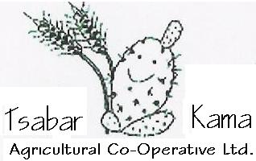

Tsabar Kama – Agricultural Co-Operative Ltd.
Principal Facts:
Tsabar Kama is an agricultural co-operative that was founded at the beginning of 2000 by 4 kibbutzim – Revadim, Tsuba, Ma’ale Hachamisha and Kiryat Anavim to farm field crops. The co-operative is wholly owned by the 4 kibbutzim and the shares are divided according to the area of allocated land that each kibbutz brought into the partnership.
The principal goal of forming the co-operative was to take advantage of the reduction in the costs of production that results from the size factor as opposed to the past when each kibbutz worked it’s own land - not very efficiently. At the start, it became clear that beyond the basic size advantage of activating one large system, the co-operative could easily allocate resources to examine development other than field crops. Today, the co-operative farms 16,400 dunam (4100 acres) and the logistical base and offices are on Kibbutz Revadim situated near all the areas worked by the co-operative. The co-op employs 12 permanent workers most of whom are members of the partner kibbutzim.
As part of the development in addition to field crops, in 2001 the co-op planted 800 dunam (200 acres) of olive trees for oil as well as a further 150 dunam in 2007 making it one of the largest producers of olives for oil in the industry. Further developments are planting of 1700 dunam of almond trees – 1000 dunam of which produced fruit for the first time in 2007. In addition we planted 120 dunam of pomegranates. We also bought a partnership in a factory providing peeled, wrapped and cooled fresh fruit like pomegranate seeds, pomelo, fruit salad, Muesli Health Delicassy etc.
The business basis of the co-operative remains the field crops whose yields facilitate the extra activity. Amongst the main crops are cotton, wheat for seeds, maize, humus, sunflowers and watermelons. We are examining other activities including building an olive oil press.

Jeff Nir
Thanks Vivian for translation

